**Answer 1 :**

#include <stdio.h>

int main()

{

int bill;

float discounted;

printf("Enter you Bill amount:");

scanf("%d",&bill);

if(bill>5000)

{

discounted=bill*(90.0/100);

printf("your Bill after discount is:%f",discounted);

}

else

printf("Payable Bill :)");

}

Output:

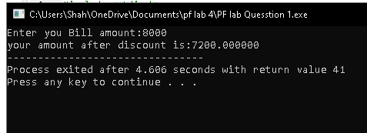

**Answer2**

#include<stdio.h>

void main()

{

int age ,price;

printf("Enter your age:");

scanf("%d",&age);

if(age<12)

{

price=200;

printf("Ticket price is:%d",price);}

else if(age<18&&age>12){

price=300;

printf("Ticket price is:%d",price);

}

else if(age>18&&age<60)

{

price=500;

printf("Ticket price is:%d",price);

}

else if(age>60)

{

price=250;

printf("Ticket price is:%d",price);

}

else

{

printf("invalid age");

}

}

Output

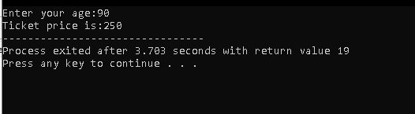

**Answer3**

#include<stdio.h>

void main()

{

int x ,y,z;

printf("Enter 3 numbers:");

scanf("%d\n%d\n%d",&x,&y,&z);

if(x>y&&x>z)

{

printf("%d is largest",x);

}

else if(y>x&&y>z)

{

printf("%d is largest",y);

}

else if(z>x&z>y)

{

printf("%d is largest",z);

}

}

Output:

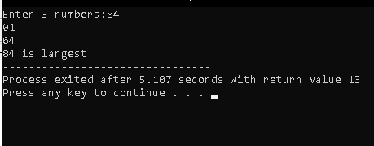

**Answer4**

#include <stdio.h>

int main()

{

int age, salary;

printf("Enter your age: ");

scanf("%d", &age);

printf("Enter your salary: ");

scanf("%d", &salary);

if (salary >= 40000 && age >= 25)

{

printf("Loan Approved ");

}

else

{

printf("Loan Rejected ");

}

return 0;

}

Output

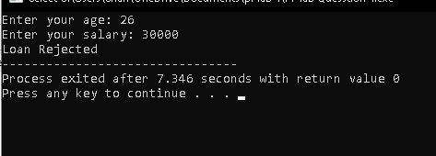

**Answer5**

#include <stdio.h>

int main()

{

int num1, num2,add, sub,mult;

float div;

char calc;

printf("Enter number1:");

scanf("%d",&num1);

printf("Enter number2:");

scanf("%d",&num2);

printf("Enter + for addition\n Enter - for subtraction \n Enter * for Multiplication \n Enter / for division:");

scanf(" %c",&calc);

switch(calc){

case '+':

add=num1+num2 ;

printf("ADDITION IS=%d",add);

break;

case '-' :

sub=num1-num2;

printf("SUBTRACTION IS=%d",sub);

break;

case '*' :

mult=num1*num2;

printf("MULTIPLICATION IS=%d",mult);

break;

case '/' :

div=(float)num1/num2;

if(num2!=0){

printf("DIVISION IS=%f",div);}

else

printf("not valid");

break;

default:

printf("Not valid");

break;

}

}

Output

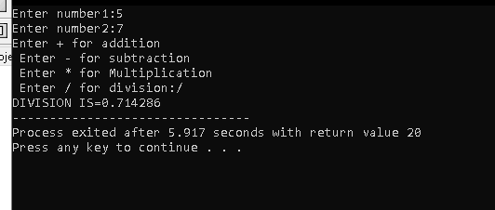

**Answer 6**

#include <stdio.h>

int main()

{

int age;

printf("Enter your age: ");

scanf("%d", &age);

if (age >= 18)

{

printf("Eligible to Vote");

}

else

{

printf("Not Eligible");

}

return 0;

}

Output

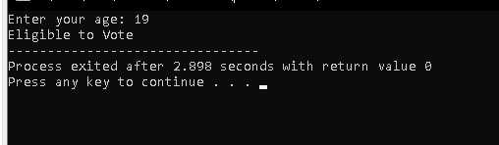

**Answer 7**

#include <stdio.h>

void main()

{

int pass,user;

pass=1234;

printf("Enter Password:");

scanf("%d",&user);

if(user==pass)

{

printf("Access Granted");

}

else

printf("Access denied");

}

Output

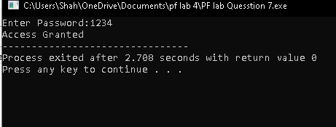

**Answer 8**

#include <stdio.h>

void main()

{

int temperature;

printf("Enter temperature in degrees:");

scanf("%d",&temperature);

if(temperature>30)

{

printf("Hot Day");

}

else

printf("Pleasant Day");

}

Output

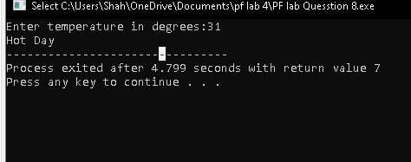

**Answer 9**

#include <stdio.h>

void main()

{

int attendance, marks;

printf("Enter your attendance percentage: ");

scanf("%d", &attendance);

printf("Enter your internal marks: ");

scanf("%d", &marks);

if (attendance >= 75 && marks >= 40)

{

printf("Eligible for Final Exam");

}

else

{

printf("Not Eligible for Final Exam");

}

}

Output

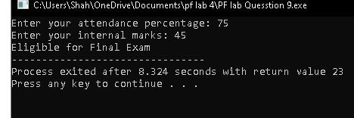

**Answer 10**

#include <stdio.h>

void main()

{

int balance, withdraw;

printf("Enter your balance: ");

scanf("%d", &balance);

printf("Enter withdrawal amount: ");

scanf("%d", &withdraw);

if (balance > withdraw && withdraw % 500 == 0)

{

printf("Withdrawal Successful");

}

else

{

printf("Withdrawal Rejected");

}

}

Output

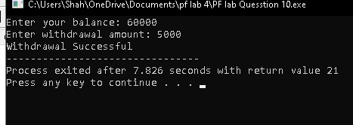

Homework Questions

Answer 1:

#include <stdio.h>

#include <string.h>

int main()

{

char email[50], password[50];

printf("Enter your Email: ");

scanf("%s", email);

if (strcmp(email, "admin@gmail.com") == 0)

{

printf("Enter your Password: ");

scanf("%s", password);

if (strcmp(password, "admin123") == 0)

{

printf("Access Granted ✅");

}

else

{

printf("Invalid Password ");

}

}

else

{

printf("Invalid Email ");

}

return 0;

}

Output

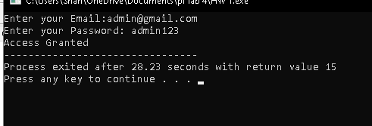

Answer 2

#include <stdio.h>

#include <string.h>

int main()

{

char nationality[20];

int age;

printf("Enter your nationality: ");

scanf("%s", nationality);

printf("Enter your age: ");

scanf("%d", &age);

if (age > 18 && strcmp(nationality, "Pakistani") == 0)

{

printf("You are Eligible"); }

else

{

printf("Not Eligible");

}

return 0;

}

Output

